Mad World.
Gary Jules.

Gary Jules : Capo 1
Tears for Fears : Capo 2

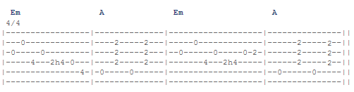

Rythmique : Bas – Bas–Haut – Haut–Bas–Haut (4 temps)

Verses: Em (Mim) G (Sol) D (Ré) A (La)
Chorus: Em (Mim) A (La)

Verse 1: Em G D A
All around me are familiar faces.
Worn out places. Worn out faces.
Bright and early for their daily races.
Going nowhere. Going nowhere.
And their tears are filling up their glasses.
No expression. No expression.
Hide my head; I want to drown my sorrow.
No tomorrow. No tomorrow.

Chorus: Em A
And I find it kinda funny.
I find it kinda sad.
The dreams in which I'm dying
Are the best I've ever had.
I find it hard to tell you
Cuz I find it hard to take.
When people run in circles it's a very, very

Em A
Mad world.
Em A
Mad world.

Verse 2: Em G D A
Children waiting for the day they feel good.
Happy birthday. Happy birthday.
Made to feel the way that every child should.
Sit and listen. Sit and listen.
Went to school and I was very nervous.
No one knew me. No one knew me.
Hello, teacher tell me what's my lesson?
Look right through me. Look right through me.

Chorus: Em A
And I find it kinda funny.
I find it kinda sad.
The dreams in which I'm dying
Are the best I've ever had.
I find it hard to tell you
Cuz I find it hard to take.
When people run in circles it's a very, very

Em A
Mad world.
Em A
Mad world.
Em A
Mad world.
Em A
Mad world.

