Creep.
Radiohead.

Rythmique 1 : Bas – Bas – Haut – Haut – Bas – Bas – Bas – Haut (4 temps)

Rythmique :
Bas – Bas – Haut – Bas – Bas – Haut I Haut – Bas – Haut – Bas I Bas – Haut I (4 temps)

G(sol) x8…
When you were here before
B(si)
Couldn't look you in the eyes
C(do)
You look like an angel
Cm(dom)
Your skin makes me cry

G
You float like a feather
B
In a beautiful weather
C
I wish I was special
Cm
You're so fucking special

Chorus:
G
But I'm a creep
B
I'm a wierdo
C
What the hell am I doin' here
Cm
I don't belong here

I don't care if it hurts
I wanna have control
I wanna perfect body
I want a perfect soul

I want you to notice
When I'm not around

You're so fuckin' special
I wish I was special....

(then something like this...)
oooh... she's running away....she's running...run..run...run..ruuuuun

Whatever makes you happy
Whatever you want
You're so fucking special
Wish I was special...

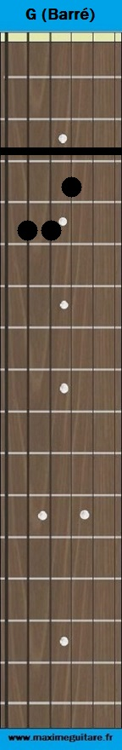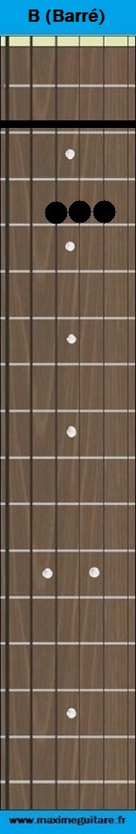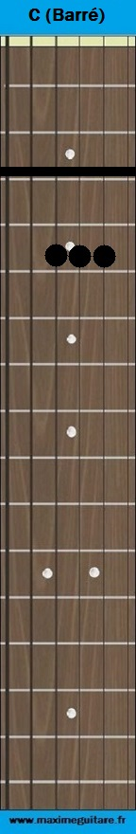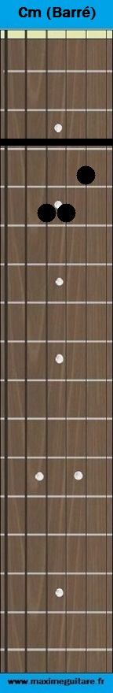
SOL SI Do Dom

